Db2 pureScale with Light Speed Networking on AWS
Modern databases must meet customer expectations in many key areas including functionality, availability, recoverability and performance. When it comes to Online Transaction Processing (OLTP) workloads, Db2 pureScale stands as the premier Db2 solution, delivering unmatched availability and seamless scale-up and scale-out performance. To achieve this, a key design requirement is ultra-low latency communication between Db2 members (the database engines) and the Cluster Caching Facilities (CFs), where critical cluster-wide decisions and caches are maintained.
Since the inception of Db2 pureScale in 2009, Remote Direct Memory Address (RDMA) has been the preferred transport method for internode communication between the Db2 members and CFs for the most demanding workloads. RDMA is a technology that allows two hosts to talk with each other without involving the CPU or the operating system. Data is transferred directly from the memory region of one host to another. The lower overhead at the system level greatly reduces latency and provides much higher throughput when compared to the traditional Transmission Control Protocol/Internet Protocol (TCP/IP) network stack. But until recently, instances of Db2 pureScale in the AWS environment were not able to take advantage of this faster network interconnect because it was not available.
In this blog, we are going to introduce a new implementation for the RDMA stack in pureScale that was developed specifically for AWS environments that support Elastic Fabric Adapters (EFA). In the next section we start describing the traditional RDMA stack, and then we follow with a discussion on EFA, followed by a comparison between the multiple transports, showing an average 40% performance improvement across the board for EFA when compared with TCP/IP, and highlighting the more than 100% improvement between Db2 v12.1.2 and Db2 v12.1.3 for the most demanding transactional workloads.

Introduction to RDMA
The RDMA stack for Db2 pureScale on premise utilizes the open-source Verbs provider with RDMA communication manager (rdma_cm). Verbs are a set of APIs that enables applications to interact and request specific RDMA operations such as remote write or read. Verbs also provides the capability to notify the application once a RDMA operation has been completed when paired up with a completion event channel. Above these low-level RDMA operations, rdma_cm on the other hand is the layer responsible for any non RDMA data transfers between the two hosts, including establishing the initial connection, exchanging handshake information and informing the application when a remote side has disconnected.
To perform a RDMA data transfer, the local host must place any outbound data in their send queue and process it in the form of a work request. The data will later be received by the remote host in their receive queue. These queues are often referred to as Queue Pair (QP). QP are associated with a transport mode dictating the RDMA operation they support and how they are performed. For example, the QP in rdma_cm uses Reliable Connection (RC) which supports most RDMA operations, including RDMA write, read and send. It also guarantees that the data arrives on the remote side and in the same order they were sent. Another characteristic of RC is that a single QP is preferred for each connection as opposed to multiple connection sharing a single QP

Sample RDMA Application
The following flowchart shows an example of an application using Verbs and rdma_cm
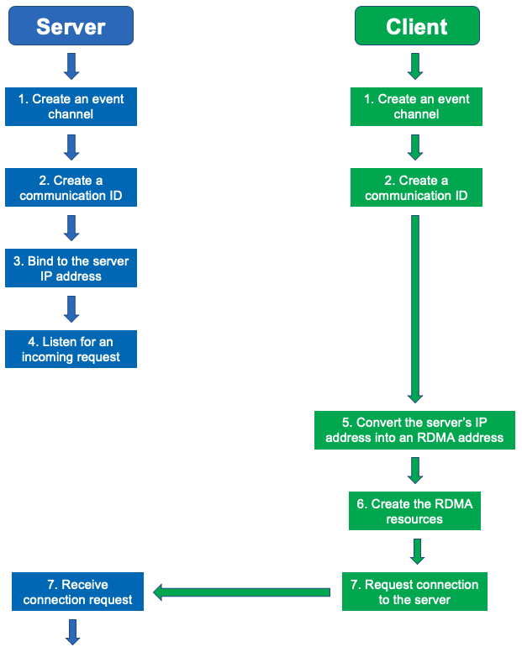
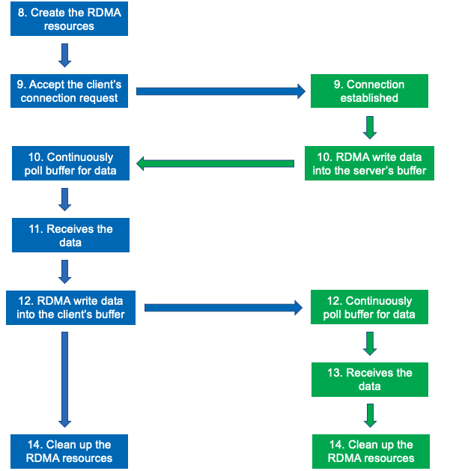
Figure 1. Simple Verbs (RC) application flowchart
Below is an explanation of the flowchart

Server Flow:
- Create a channel (endpoint) used to exchange communication events (non RDMA)
- Create an RDMA identifier used to track communication information
- Bind the RDMA identifier to the local IP address
- Start listening for incoming client connection request.
- No action required
- No action required
- Receive the client connection request
- Create all the RDMA resource(s)
  - Protection Domain (Ensures only authorized RDMA resources can interact)
  - Completion Channel (Notifies application when RDMA operation completes)
  - Completion Queue (Holds completed RDMA operation)
  - Queue Pair (Used to perform RDMA operation)
  - Memory Region (RDMA registered memory location)
- Accept the client connection request (RDMA resource information is sent as part of this request)
- Wait for data to arrive on the local memory region
- Process the data
- Send data to the remote memory region
- No action required
- Cleanup all resource(s)
Client Flow:
- Create a channel (endpoint) used to exchange communication events (non RDMA)
- Create an RDMA identifier used to track communication information
- No action required
- No action required
- Resolves both local and remote (server) IP addresses to an RDMA address
- Create all the RDMA resource(s) (Same as Server)
- Attempt to connect to the server
- No action required
- Exchange RDMA resource information
- Send data to the remote memory region
- No action required
- Wait for data to arrive on the local memory region
- Process the data
- Cleanup all resource(s)

Introduction to EFA
When Db2 pureScale was first introduced on AWS, it only supported the TCP/IP network stack for Db2 member to CF communication. TCP/IP networking drives significant OS-level CPU utilization which can limit scalability as the amount of network traffic required to coordinate work between nodes grows exponentially. The limits on scalability become more evident in workloads that perform many write or update operations. AWS does not support the Reliable Connection Queue Pair model commonly seen in RDMA over Converged Ethernet (RoCE) but provides an alternate RDMA solution called Elastic Fabric Adapters (EFA). EFA offers similar RDMA capabilities such as CPU and operating system bypass, allowing customers on Amazon EC2 instances to run applications requiring high levels of inter-node communications at scale. A new proprietary QP transport mode called Scalable Reliable Datagram (SRD) was developed by AWS to be used specifically for EFA, and Db2 integrated this into pureScale to allow Db2 pureScale instances running in EC2 instances that support this transport to leverage this high-performance networking.
SRD shares a similar design to the Reliable Datagram (RD) model in which multiple different connections are associated with a single QP (N: 1) as opposed to RC where only one connection exists for each QP (1: 1). This provides significant improvements in the scalability of the solution for larger size clusters and reduces the overall memory usage cost. However, the tradeoff being the limitation on the number of available QPs per network interface when compared to a transport that supports RC.
Below highlights the significant difference in these numbers between Verbs (RC) and EFA (SRD):
> ibv_devinfo -d mlx5_0 -v | grep qp
max_qp: 131072
max_qp_wr: 32768

Figure 2. Verbs (RC) device information

> ibv_devinfo -d rdmap0s31 -v | grep qp
max_qp: 256
max_qp_wr: 4096

Figure 3. EFA (SRD) device information

Applications already designed to use the RC model such as Db2 pureScale would need to pivot to a shared QP approach to fully utilize SRD capabilities. Instead of creating a new QP for each new connection between Db2 Members and CFs like pureScale does when using Verbs (RC), a predefined number of QPs will be created upfront during instance startup for EFA (SRD). Every new connection going forward for EFA will associate itself with an existing QP from the pool in a round robin fashion. This aligns better with the SRD design and reduces the overall consumption of QPs for each database connection. However, there are still some architecture challenges as QP can only be shared by connections talking to the same destination host. Db2 pureScale supports multipoint communication, meaning each CF host can service multiple different Db2 Member hosts at once. This greatly restricts the number of shareable connections results in a much lower number of concurrent database activations compared to RC.

Key differences when working with EFA compared to RDMA Verbs

Out-of-order Packet Delivery
Another key difference is SRD delivers packets out-of-order meaning there is no guarantee the data will arrival in the same order they were sent. Out-of-order delivery reduces queuing latency since packet drops no longer delay the transmission of other packets. Applications which require ordered delivery must wait for the previous data to arrive before sending the next one. This is achieved by requesting a work completion event for each RDMA operation, then polling the completion queue until the corresponding work completion event is generated. This is also referred to as signaled send.
Un-signaled send as the name suggests is where data is transmitted to a remote host without generating a work completion event on the associated completion queue for RDMA operations. The benefit of un-signaled send is that the host can avoid spending CPU time to process work completions events, which results in around 10% performance boost when compared to signaled send. The majority of RDMA operations in Db2 pureScale are performed using un-signaled sends since work completions events for RDMA operations typically do not contain useful information that the application does not already know. Unfortunately, EFA currently only supports signaled sends meaning each RDMA operation must generate a work completion event, and the completion queue must be emptied out in a timely manner to prevent RDMA operations failing once it fills up. To preserve similar performance to un-signaled send, RDMA operations in Db2 pureScale using EFA do not wait for its corresponding work completion event, and the completion queue needs to be periodically purged to ensure it does not fill up.

Scatter Gather Element.
Another area that needed to be adapted when adding support to EFA was the Verbs Scatter/Gather Element functionality that pureScale uses to consolidate data transfers when using Verbs. This allows a single RDMA operation to write data to multiple different memory locations through a remote buffer. Unfortunately, the number of SGE Db2 pureScale uses (16) is more than what EFA supports (2). The solution is to store all the SGE data into one contiguous memory block, allowing the use of a single SGE to achieve similar results with EFA as with Verbs.

Connectionless Protocol
The other difference that required adaptation was the mechanism that pureScale implements to handle remote connection terminations, something that is important to handle network failure scenarios. In the general implementation with Verbs using rdma_cm pureScale uses a connection-oriented approach, meaning there is a dedicated service on both ends listening and retrieving incoming events and handling any remote connection terminations. Now in the case of EFA, it uses a connectionless approach, meaning there are no mechanisms to automatically detect or receive disconnect events. This is problematic for pureScale since the Db2 Member and CFs could still be sending data on a stale connection without noticing the communication failure.
The solution developed for Db2 pureScale v12.1.2 onwards for EFA support was to replace the rdma_cm layer with a TCP/IP connection. The initial connection establishment, handshake information exchange and disconnect handling are be done using the TCP/IP stack. This should not affect the overall performance since the CFs commands will still be using RDMA. There will be dedicated threads on both sides to constantly monitor socket file descriptor events on this TCP/IP connection. In addition, a special socket flag will be used so an event will only be generated if the remote connection closes. During the monitor, if no events are detected, then the connection is healthy. Any event will deem the connection broken since EFA does not perform data transfer using TCP/IP outside the initial handshake stage. The diagram below showcases an updated flowchart for EFA. The key difference being Verbs (RC) uses rdma_cm for all non RDMA related communications while EFA uses sockets.
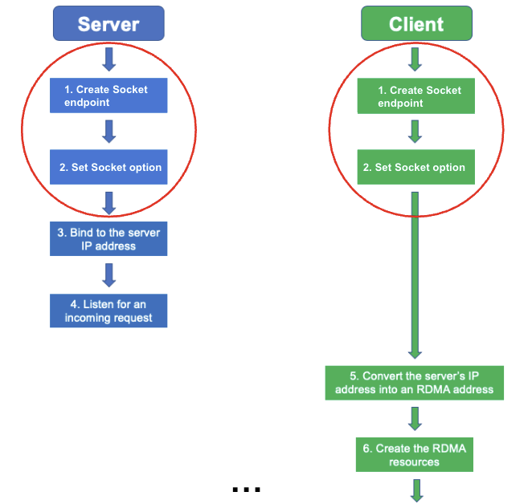
Figure 4. Comparison flowchart between EFA(SRD) and Verbs (RC)

Comparing the Performance of EFA and TCP/IP
The chart below shows the transaction per second (TPS) between EFA and TCP for 3 members with varying amounts of read/write ratio (50,70,90) and number of clients. Each host is a m6i.32xlarge EC2 instance, with 128 CPUs and 512Gb RAM, using Multi-attach EBS storage configured with 20,000 IOPs.
The benchmark used is IBM’s Db2 Transactional Workload (DTW) which is a variation on TPC-C. It is an OLTP workload that performs concurrent inserts, updates, deletes and queries against the database using Cursor Stability isolation levels. The mix of statements can be configured to reflect different read/write levels, where 50% write is broadly equivalent to one Insert/Update/Delete SQL for every one Select SQL statement.
EFA vs TCP/IP
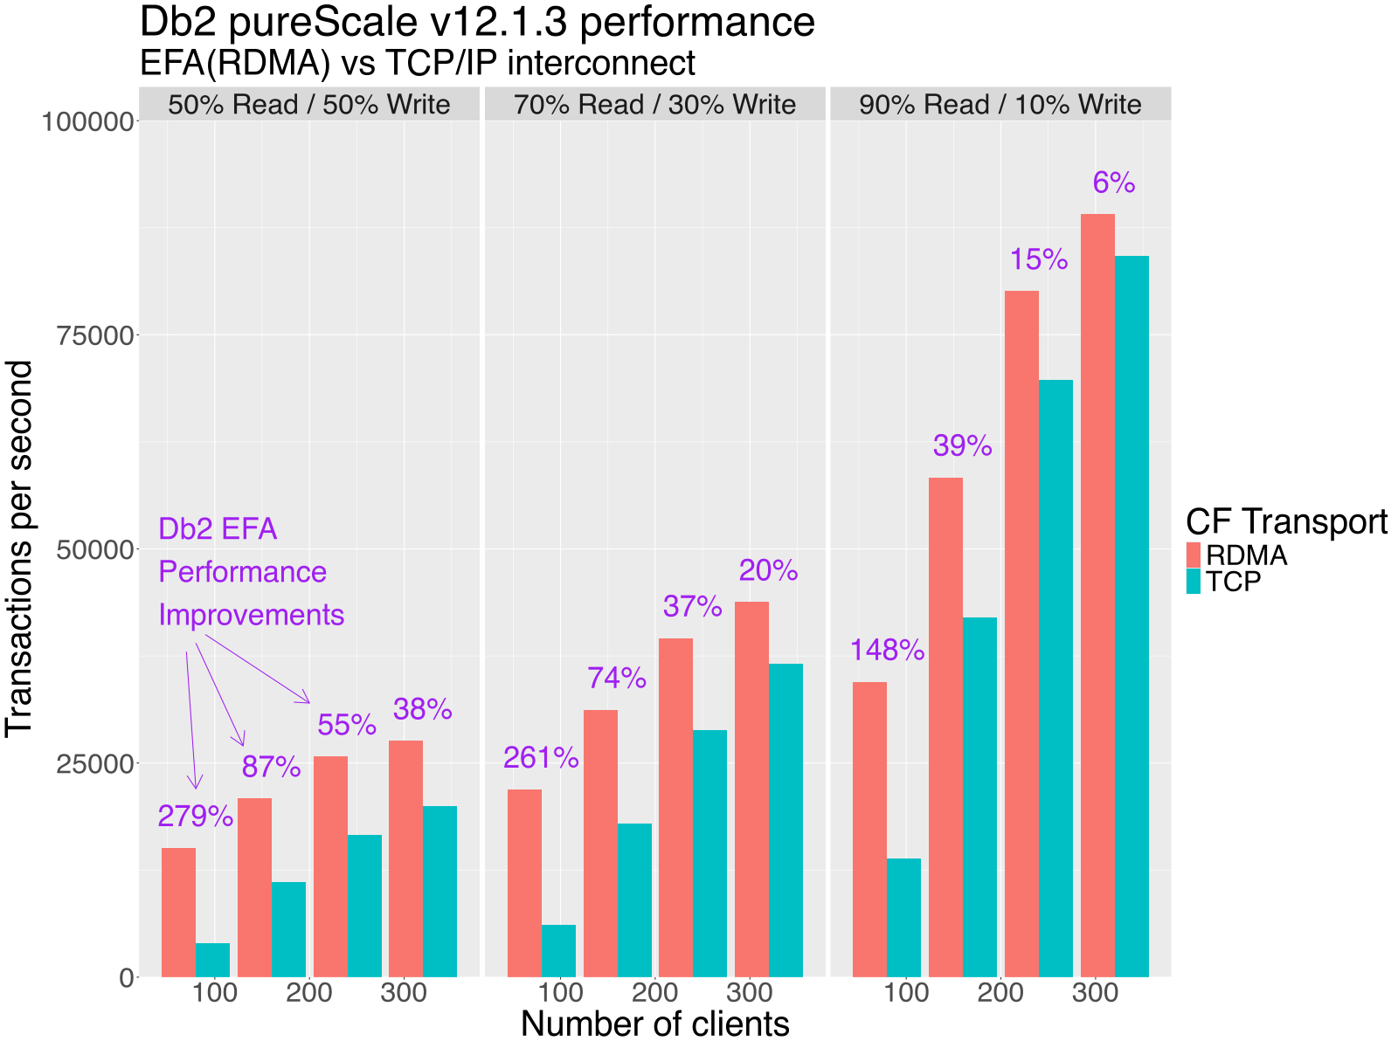Figure 5. Comparison graph between EFA vs TCP

On average, there is about a 40% performance improvement across the board for EFA when compared with TCP/IP, with peaks at 87% performance improvement. The most significant boost can be seen for write heavy workloads and lower number of clients with upwards of doubling the TPS. As the number of client increases, the transaction rate starts to plateau due to limitations on log transaction writing, among other effects.

Db2 v12.1.3 brings more performance
During the extensive testing of EFA support in Db2 v12.1.2, the highest activity workloads showed signs of bottlenecks in the EFA transport layer. Investigation identified cross-invalidate (the process of marking local bufferpool pages as invalid after another member has modified the page) as a critical area for improvement, and that work has landed in the Db2 v12.1.3 modpack. Taking an approach from the existing TCP/IP transport layer, the revised implementation sends multiple cross-invalidate requests in batches.
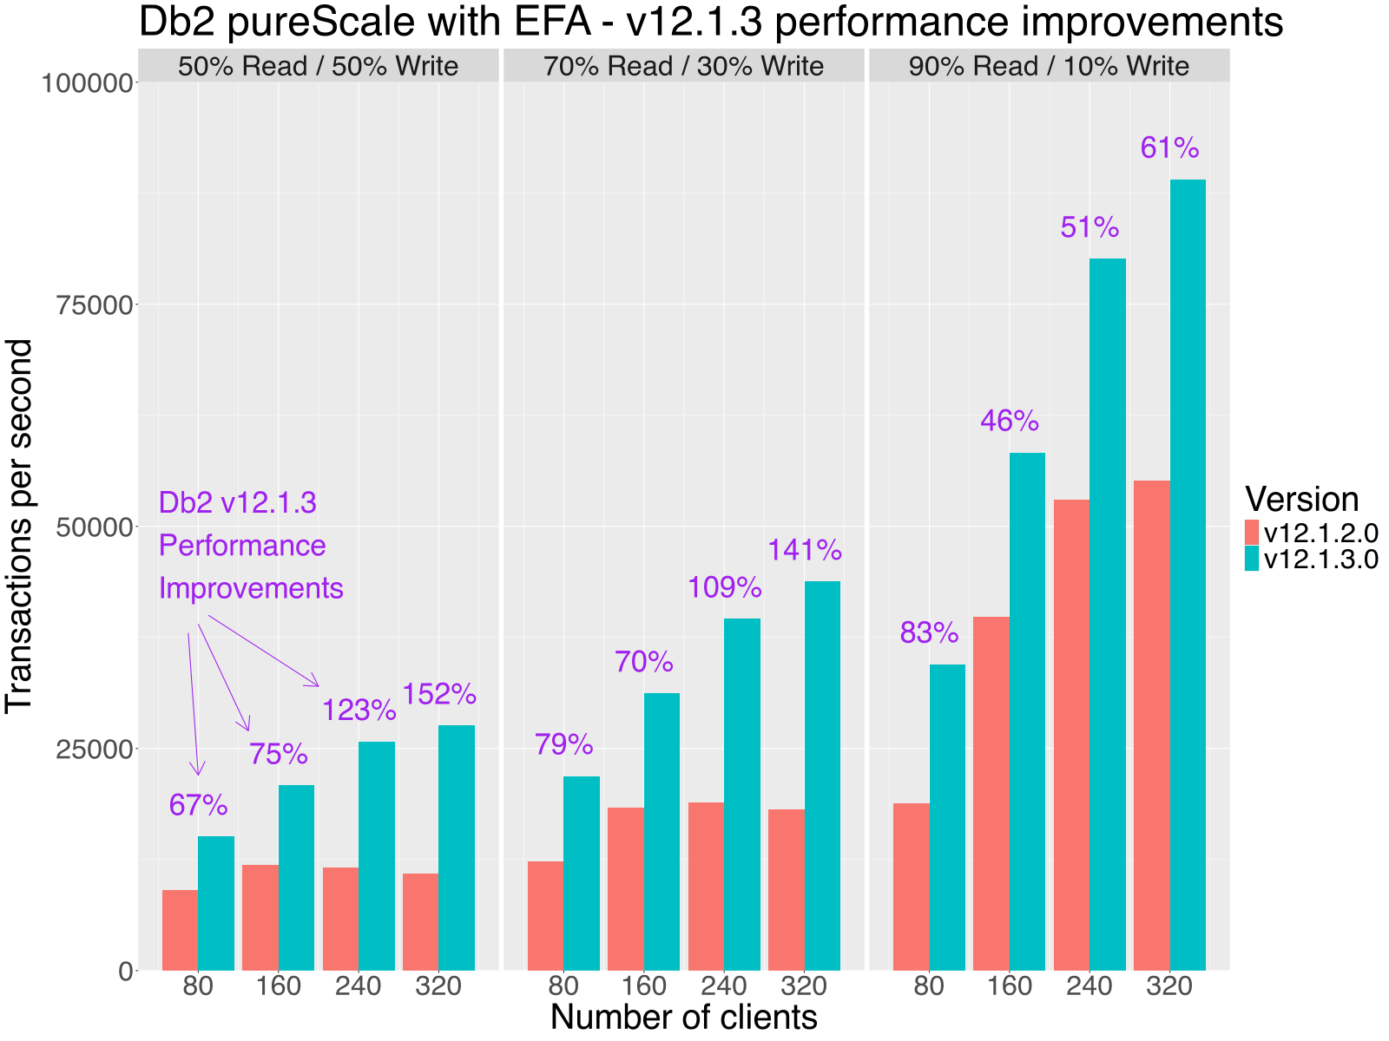
Figure 6. Comparison graph between Db2 v12.1.2 vs Db2 v12.1.3

The chart above shows the impact of resolving this bottleneck, with the most demanding workloads doubling the transactional throughput.

Closing remarks
Databases engines need to be able to make use and exploit any technology that helps accelerate database workloads. Elastic Fabric Adapter has a different approach to RDMA compared to the RoCE and InfiniBand networking solutions that Db2 pureScale has used to date. Getting the best performance from EFA requires understanding the characteristics of EFA network handling, and Db2 pureScale can now showcase the substantial performance improvements that users can expect when deploying on an AWS cluster with EFA capabilities.

About the Authors
Tony Wang is a member of the Db2 pureScale and High Availability team at the IBM Toronto Lab and holds a BSc in Computer Science from McMaster University. He began his career at IBM as a Software Developer Intern in 2017 before transitioning into a full-time Software Developer position in 2019. Tony specializes in various components of Db2 pureScale, including the Cluster Caching Facility (CF), networking with Remote Direct Memory Access (RDMA), and cluster manager services.
With a background in Observational Astronomy at the University of Cambridge, England, Toby Haynes joined IBM Canada in 1999 as a software developer in the Db2 Runtime engine. After eight years of development experience, he moved over to the Db2 Performance team to start work on what would become Db2 pureScale v9.8, working under Steve Rees. In the late summer of 2018, he stepped up to the role of Technical Manager for Db2 pureScale, looking after an active team of developers and support analysts. Now a Senior Software Developer at IBM, Toby is examining many areas of Db2 for robustness, usability and performance excellence.
Christian Garcia-Arellano is STSM and lead architect in the DB2 Kernel Development team at the IBM Toronto Lab and has a MSc in Computer Science from the University of Toronto. Christian has been working in various DB2 Kernel development areas since 2001. Initially Christian worked on the development of the self tuning memory manager (STMM) and led various of the high availability features for DB2 pureScale that make it the industry leading database in availability. More recently, Christian was one of the architects for Db2 Event Store, and the leading architect of the Native Cloud Object Storage feature in Db2 Warehouse.

